VTOL Aırcraft

ME 429 Mechanical and Thermal Design



Department of Mechanical Engineering

Boğaziçi University

Metin ÖZ

Harun ÜNER

# Executive Summary

Since readers look into the executive summary before they read the entire report. An executive summary should summarize the key points of the report. It should restate the purpose of the project, highlight the major progress in the project execution, and describe any results, conclusions, or recommendations from the report.

An executive summary is usually 500-1000 words in length, it is written as one page, it may include numerical information about the procedure and the results, it should not include any information that is not reported in the report, abbreviations should not be used unless they are spelled out in the summary, citations or references are not given in the summary.

# Introduction

This section of the report usually problem statement which states why that particular subject is chosen. It establishes the importance of the subject by reviewing relevant literature, including academic papers, patents, books, web sites, etc. Relevant references are discussed and a theoretical background is provided based on the literature review. Significance of the project should be clearly stated. Already existing products and designs should be benchmarked and the drawbacks should be stated. This section should be kept brief and to the point in 8-10 pages.

# Design Process

This section should be 10-20 pages long and should include the following subsections:

## Design Criteria and Product Design Specifications

The reasons why the design criteria are chosen and the relevance of the criteria to the product in particular should be explained. All assumptions should be stated. Product design specification should be brief and clear. Use the template provided. Binary Dominance Matrix should be stated here.

## Overview of Possible Solutions

Possible Solutions should be proposed with clear sketches and explained clearly. Decision Matrix should be provided here.

## Detailed Design and Analysis

Use figures, tables, free body diagrams and/or sketches (no hand sketches!) to explain your analysis. (analytical formulations, numerical results, cost analysis)

VTOL which is an efficient combination of two flying vehicle, carries on majority of its flight time as a fixed wing. It was decided to design a fixed wing vehicle that can operate stably, and then construct the tri-copter frame on the fixed wing aircraft. The reason behind the decision is that fixed wing aircrafts have more complex and strict design parameters such as wing length, location of the CoG (Centre of Gravity), AoA (Angle of Attack) of wing etc. On the other hand, rotary-wing aircrafts can be relatively easy to adapted to different frame designs and provides a wider range for the specification of design parameters.

The most important part of the fixed wing vehicles is their wings which produce lift to keep the aircraft on-air and a significant portion the drag. For this reason, the wing design is considered as the most prioritised stage in the design process of the aircraft. The aspect was taken into account in the progress of the project and it was aimed to select the airfoil that will meet to the design criteria of the vehicle. Therefore, airfoils commonly used in commercial RC aircrafts were surveyed, and it was found three profiles that stand out with their differing advantages in application. These are NACA-6412, NACA-4412 and NACA-2412; these airfoils are shown in the *Figure 2.1*.

National Advisor Committee for Aeronautics (NACA) is an organisation founded in the USA in 1915 and conducting aeronautics research. The aerodynamic surface shapes developed and tested by the organisation, whose name has changed to NASA, are called NACA airfoils. [1] Each digit in NACA 4-digit airfoils refers specific characteristic of the airfoil. First digit refers maximum camber as percentage of the chord length, second digit refers to location of maximum camber with respect to leading edge and last two digits refer maximum thickness of the wing profile as percentage of the chord length. [2]

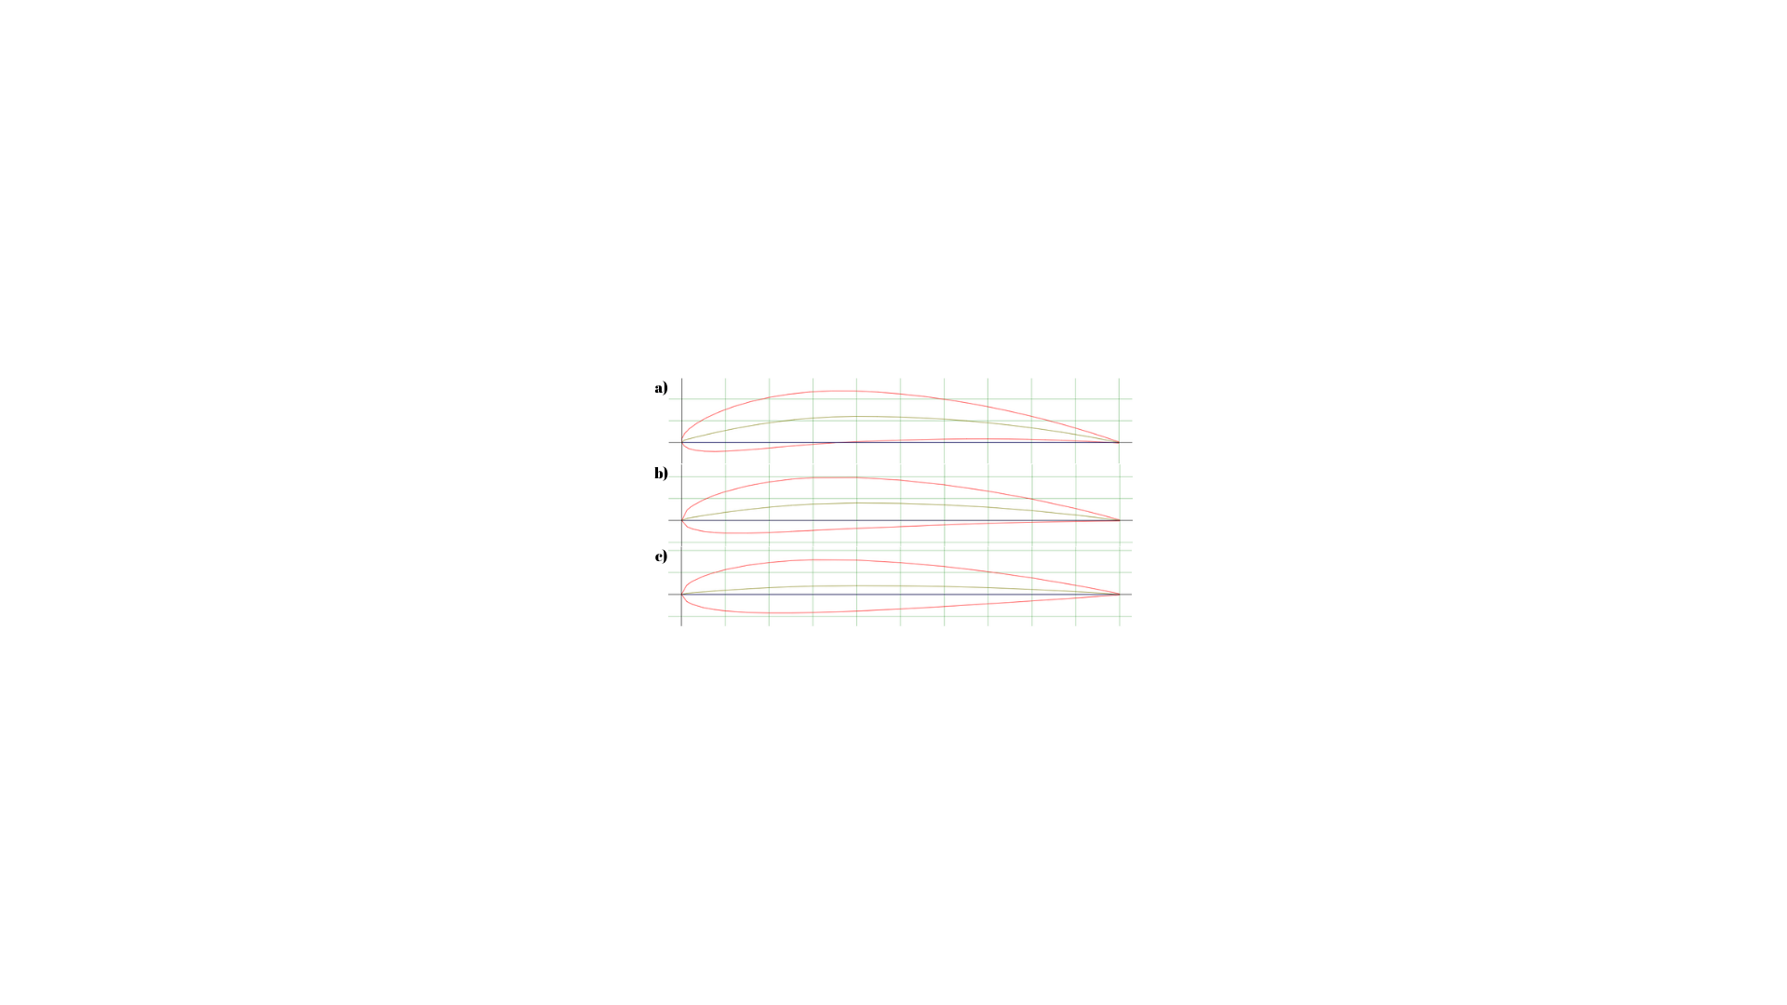

**Figure 2.1** Commonly Used Airfoils: (a) NACA-6412; (b) NACA-4412; (c) NACA-2412.

The airfoiltools.com website was used to make comparative investigation of the selected airfoils. This web tool plots α (Angle of Attack) dependent variations of $C_{L}$ (Lift Coefficient), $C_{D}$ (Drag Coefficient), $C_{m}$ (Moment Coefficient) values of the airfoil for a certain Reynolds number. As seen in the *Figure 2.2*, polar diagrams are generated for Re=100.000. NACA-6412 has a high $C_{L}$ value. NACA-2412 has a lower $C_{D}$ value at 0-5 degrees, which is the AoA of operation. NACA-4412 has intermediate values in all graphs, but it also can be an optimal option for different manufacturing techniques such as balsa spar-rib construction thanks to its semi-linear bottom line.

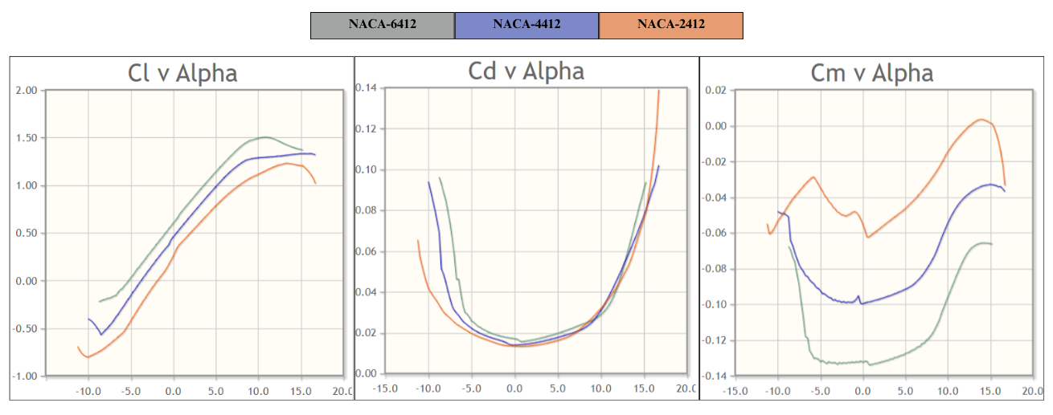

**Figure 2.2** Polar Diagrams of Airfoils (Re=100.000).

The next stage is to design a wing that can generate enough lift to compensate for the expected take-off weight at lengths and speeds within the design limitation. The wing must produce at least 15N lift force to balance minimum take-off weight at a maximum speed of 13m/s and its length must be in the range of 1300-1500mm. XFLR5, a numerical analysis and fixed wing design software, was used for this purpose.

XFLR5 is a software developed specifically for model aircraft, unmanned aerial vehicles (UAV) and small-scale fixed-wing vehicles. The program is capable of both 2D aerodynamic and 3D numerical analysis. In wing design, XFLR5 is useful with its three-dimensional analysis capability. Using the panel method, aerodynamic properties of the wing such as lift, induced drag and moment can be computed. 3D Panel Method is ideal for evaluating the performance of wings with different geometries. Furthermore, the user can determine the aerodynamic centres of the wing and stabilisers and examine the effect of in-flight moments on stability.

The process was carried out through iterations and the optimal wing geometry was tried to be obtained. The primary focus was on the lift force, while the total drag force and pitching moment were also considered. 3D Panel Analysis method was used and constant lift boundary condition was applied. 1.5 kg of point mass is located at quarter chord length from the leading edge. The algorithm calculates the minimum speed required for the wing to generate sufficient lift at different AoA values, and the software stores the operation points. Total of 6 iterations were performed. Some featured geometric parameters of the wing designs and their required minimum speed obtained from the analysis are shown in *Table 2.1.*

**Table 2.1.** Geometric Parameters and Analysis Results of Design Iterations.

|  |  |  |  |  |  |  |
| --- | --- | --- | --- | --- | --- | --- |
| Parameters | 1st  Iteration | 2nd  Iteration | 3rd  Iteration | 4th  Iteration | 5th  Iteration | 6th  Iteration |
| Wing Span *[m]* | 1.300 | 1.300 | 1.500 | 1.500 | 1.500 | 1.640 |
| Wing Area *[m2]* | 0.191 | 0.210 | 0.251 | 0.251 | 0.252 | 0.266 |
| Airfoil (NACA) | N-4412 | N-4412 | N-4412 | N-6412 | N-6412 | N-6412 |
| Root Chord *[m]* | 0.230 | 0.230 | 0.230 | 0.230 | 0.250 | 0.250 |
| M.A.C. *[m]* | 0.191 | 0.191 | 0.191 | 0.191 | 0.191 | 0.186 |
| Wing Load *[kg/m2]* | 7.843 | 7.143 | 5.970 | 5.970 | 5.980 | 5.726 |
| Tip Twist *[˚]* | 0 | 0 | 0 | 0 | -3.0 | -3.0 |
| Aspect Ratio | 8.837 | 8.048 | 8.995 | 8.955 | 8.970 | 10.10 |
| Tilt Angle *[˚]* | 2.0 | 2.0 | 2.0 | 2.0 | 3.0 | 3.0 |
| Cruse Speed *[m/s]* | 18.75 | 17.37 | 15.23 | 13.22 | 13.16 | 12.77 |
| Stall Speed *[m/s]* | 12.2 | 11.28 | 9.854 | 9.249 | 9.202 | 8.923 |

The first four designs were insufficient to produce sufficient lift force. Adequate lift force was obtained in the fifth design.

## Project Management

Work Packages (tasks and subtasks), roles of team members, resources, Ghent Chart including this term (ME 429) and next term (ME492) with clearly stated subtasks, milestones, etc.

# Discussion

This section may be 2-4 pages. In this section, statements given in Design Process are discussed and interpreted. Future work should also be stated. What further research can be done in the field you have chosen? Highlight any failures, problems or constraints that have affected progress, and describe the measures taken to respond to them. Describe key lessons learned, that are important to your project or that may be of use to others doing future work related to the project. They may relate to any of the following: successes, strategies adopted, challenges you are facing, surprise results, management processes, or technical understanding. . Explain the importance of the topic in your future professional life and society in general. Provide some self-reflection about the design and report writing process. How do you evaluate the contributions of this design process to your academic development? Do you intend to work in the future in the field in general and the topic you have chosen in particular?

# Conclusion

This section is a restatement of the information given in the report overall. No new topics are

# References

|  |  |
| --- | --- |
| [1] | National Aeronautics and Space Agency, “NASA History,” 2023 May. 11. [Online]. Available: https://www.nasa.gov/reference/the-national-advisory-committee-for-aeronautics/. |
| [2] | E. N. Jacobs, K. E. Ward and R. M. Pinkerton, “The characteristics of 78 related airfoil sections from tests in the variable-density wind tunnel,” National Advisory Committee for Aeronautics, Washington, D.C., 1933. |

# Appendices

All source codes, technical drawings with dimensions, material data sheets etc. should be givens in appendices as “Appendix A: Python source code for pattern recognition” Appendix B: “Material Data Sheet for foaming Agent” etc.